Homework 4 Analysis of 3 Way Implication
By: Clayton Burgess, Johnny Hug, Samuel Green
- PThreads
PThreads use shared memory from a single machine. So, in terms of using it, it on a supercomputer only uses one process and not a whole cluster of processes. Only using one process means that only one node can be used. To test the speed of pthreads on different variables the following tests were ran: changing the number of threads, amount of memory being used, and how many lines are read from our huge file. Each type of test was run five times and the averages of those were computed for the purpose of the graphs in this section. Two types of each test were run on different parameters to see how different variables affect the performance of the system. The first test was how the number of threads affects the performance of the system. One test was run with 1GB of RAM and 500 thousand lines were read from the file. The second test was run using 3GB of RAM on 1 million lines as shown by the first two graphs below. 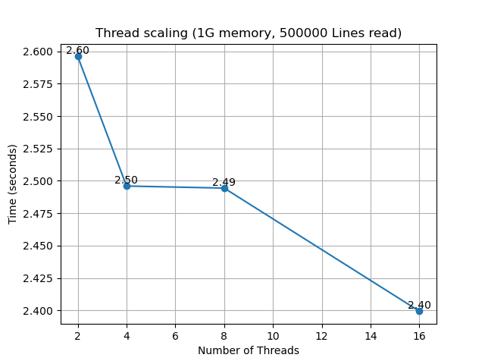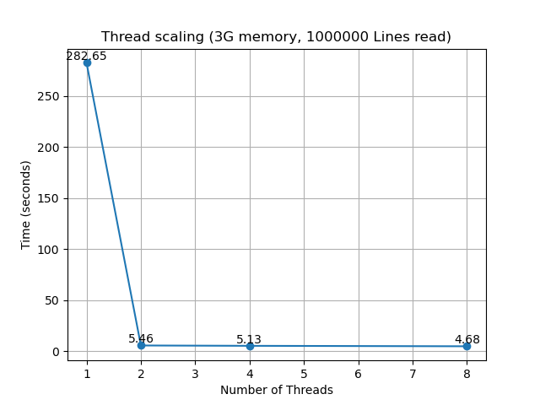
As you can see from the two graphs the one on the left is missing thread number 1, and the right is missing thread number 16. One thread will not work on that set of variables because there is not enough memory to process the lines. Same sort of thing for 16 threads except this exceeds the 1G memory easily. When using 1G the results trend downward throughout the whole range of threads. When we used 3G of data using one thread took minutes compared to the others that took just a few seconds and decreased slower as the number of threads increased.
For the next test that was run we changed the amount of memory that was used to run a certain number of threads with a certain number of lines read from the file. One was 4 threads and we processed 100 thousand lines, and the other we used 16 threads on 100 thousand lines again. Here are the results on the two graphs below. 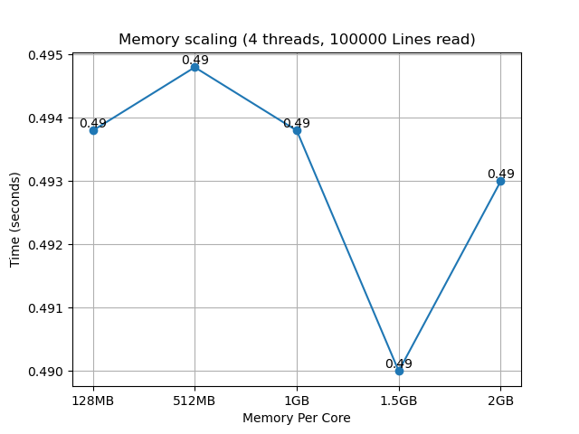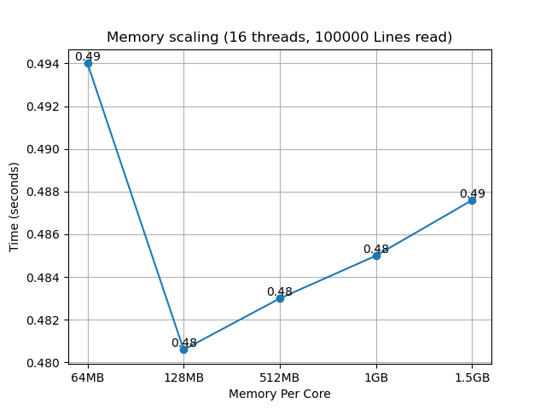
We see kind of the same trend as we did with the threads. The fewer number of threads used the lower amount of memory performed weaker than the higher amount of memory and vice versa for the higher thread. 64MB was not enough memory to process the number of rows with 4 threads and 2G with 16 threads easily went over the amount of memory we were trying to use. We also see that one is significantly lower than rest in both cases which doesn’t necessarily mean that amount of memory is optimal, there might have just been more noise for that group of runs.

The last set of tests that were performed was on how the systems react to reading different numbers of lines from the file. The constant variables for these were 4 threads on 1G and 16 threads on 512MB. Results shown below. 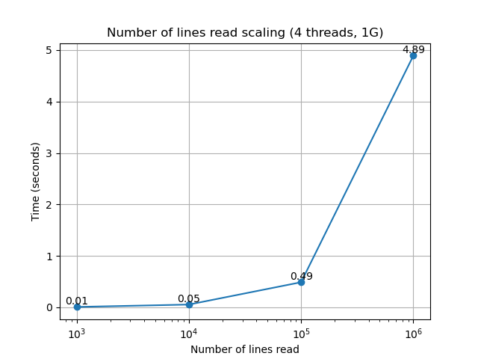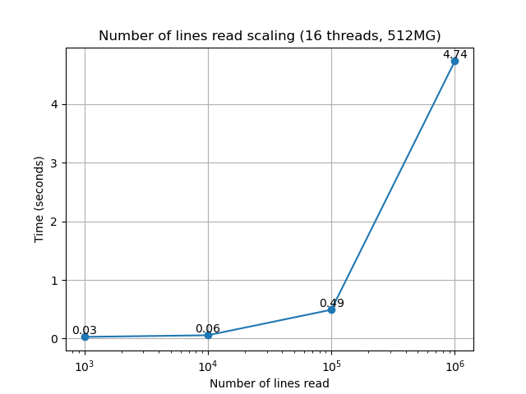
These perform very similarly and how one might expect. The greater number of rows read the more time it takes to complete the task. If we boil it down further in most instances, reading with more threads and less memory performs a tiny bit slower.
To conclude this section on Pthreads we can see that the performance between each set of tests has its similarities. However, there are a few other aspects that come into play. We can use different networks to run these tests. In the testing performed here there were no major differences noticed. On the other hand, what was noticed is that when there was a peak of jobs being run on the system there was a fair amount of inconsistencies with the data. Too big to be considered for the averages shown in the graphs as the times were jumping all around. For that purpose, those times were considered outliers and dropped for the purpose of having the most consistent data.

